BO Agent login : Data not loading

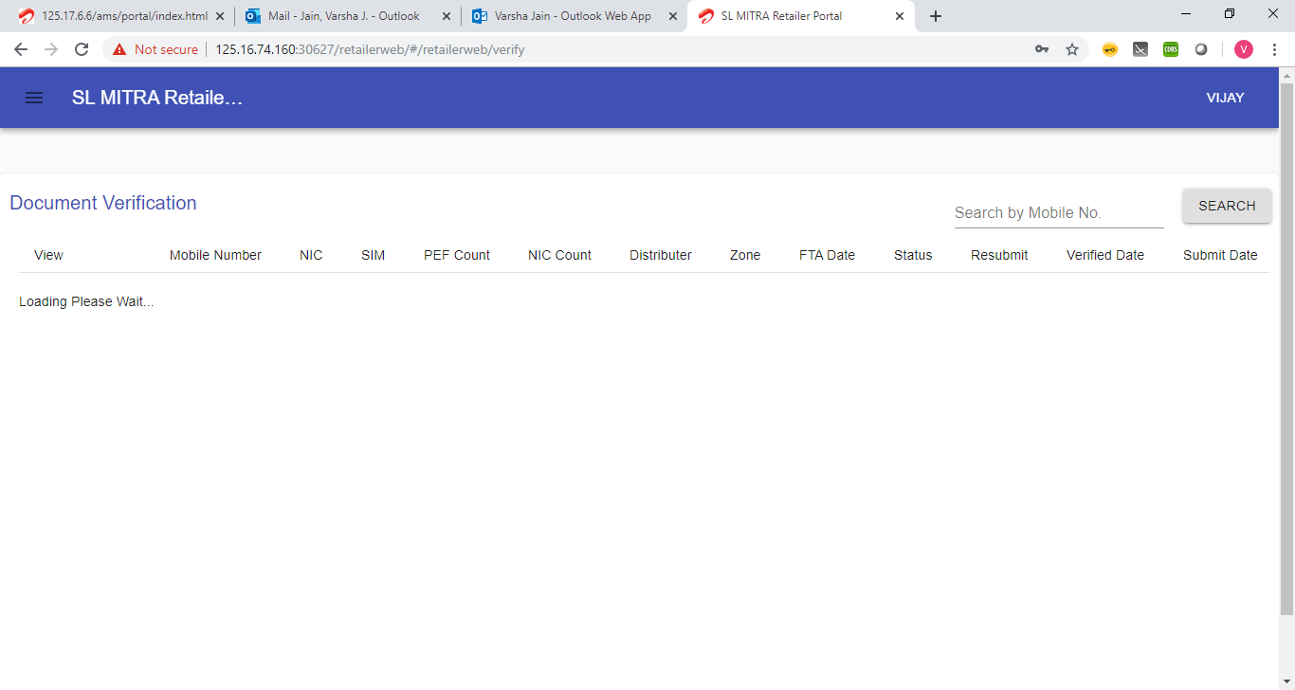

Data Entry Login

When searched for a particular number two error msgs displayed at a single instance.

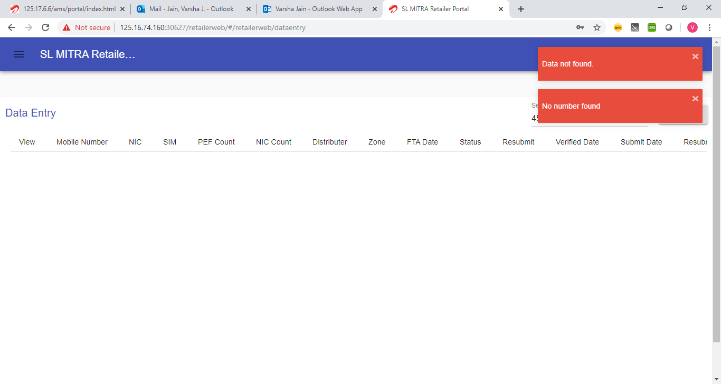

Update Acquisition is disabled.

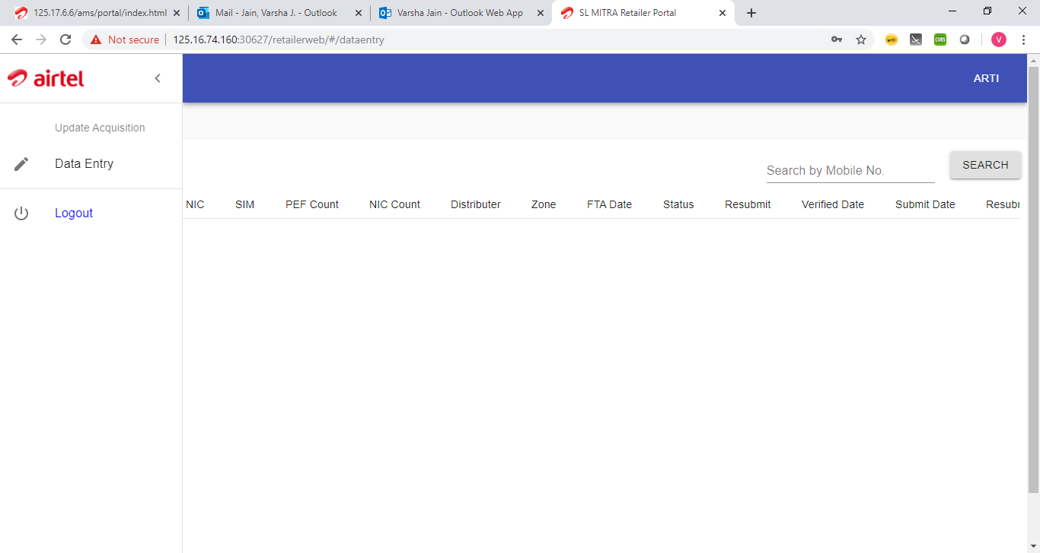

Distributor login :

While we upload a particular document , while we click on the uploaded document its cleared.

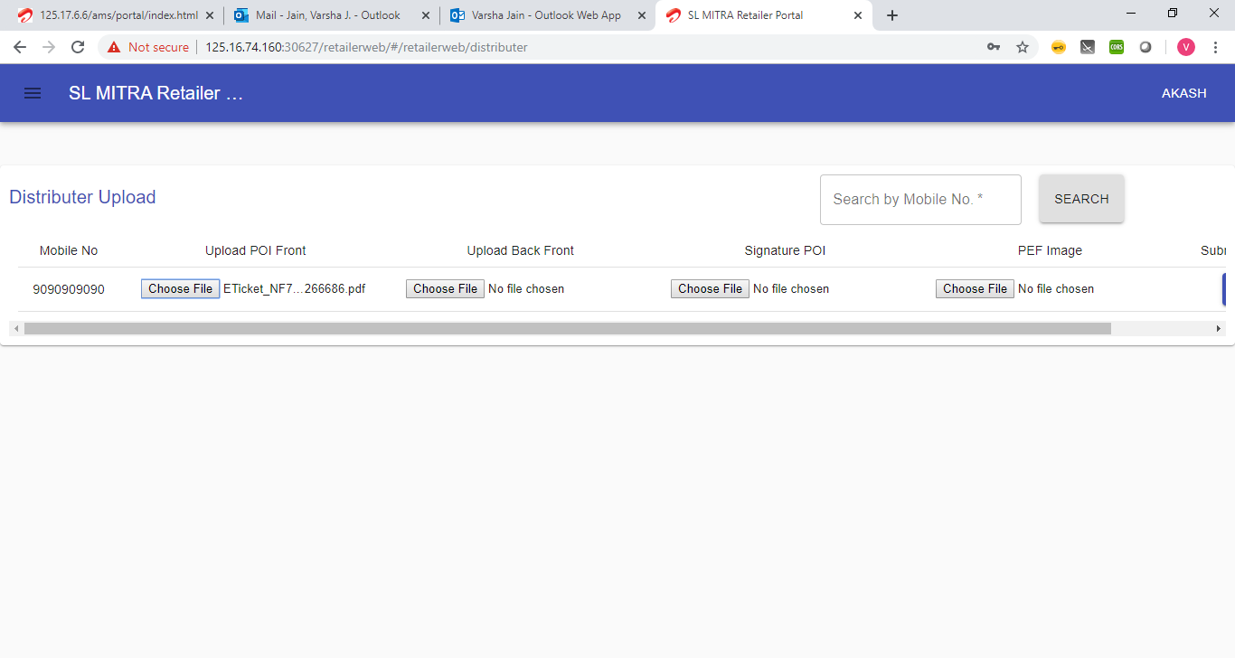

Clicking on the uploaded file deletes the file off the portal.

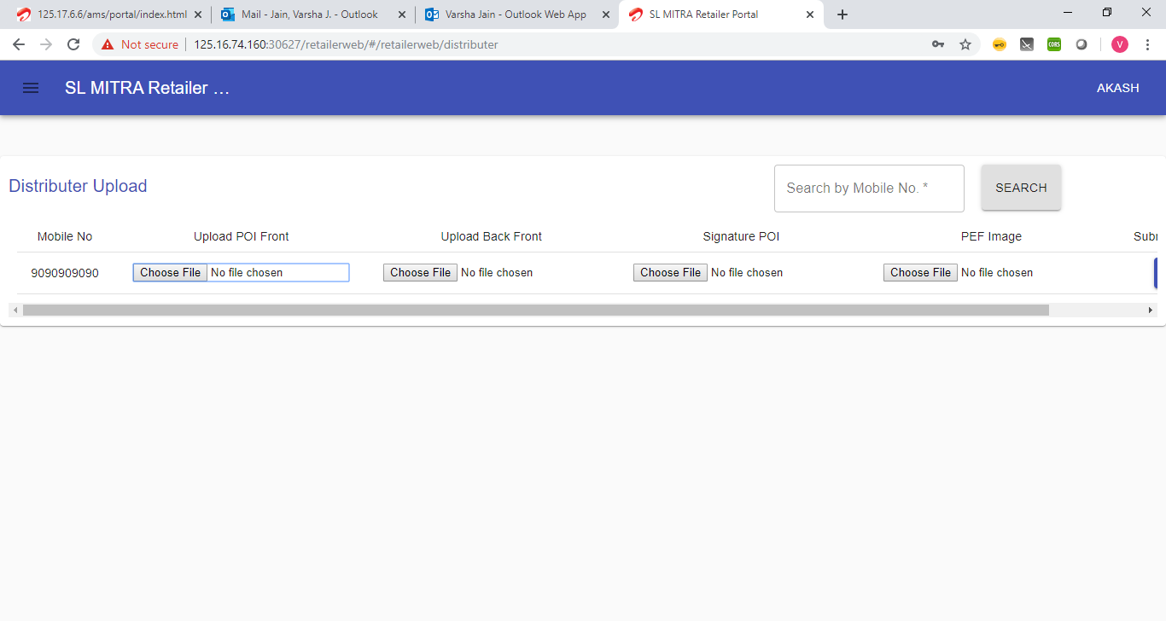

Accepts letter in search mobile num area:

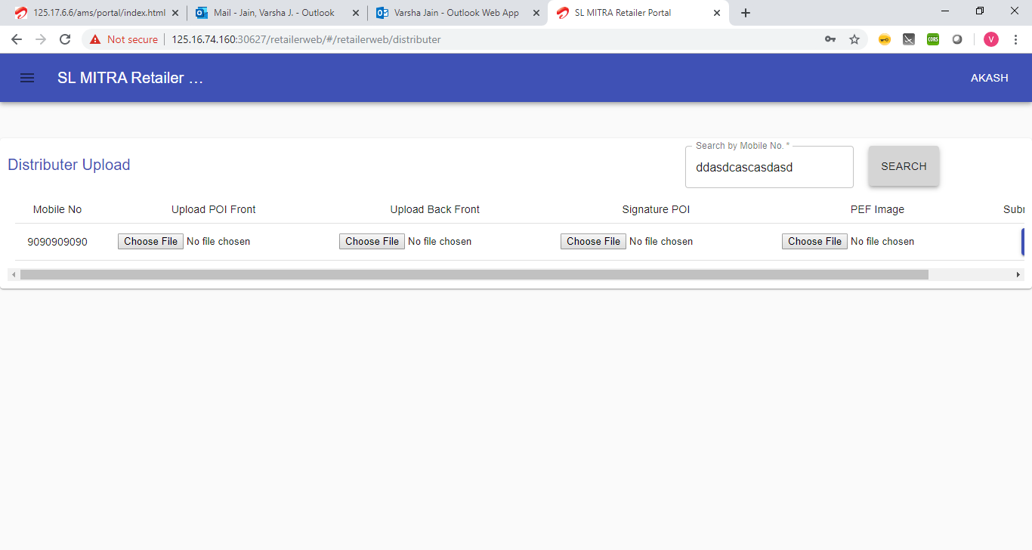

No Action on Submit button.

